LAB 8
Navigator, Hero Animation, BottomNavBar
- NAVIGATOR:
Goal screen:
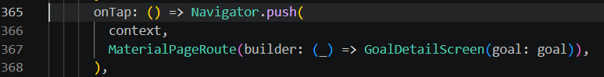
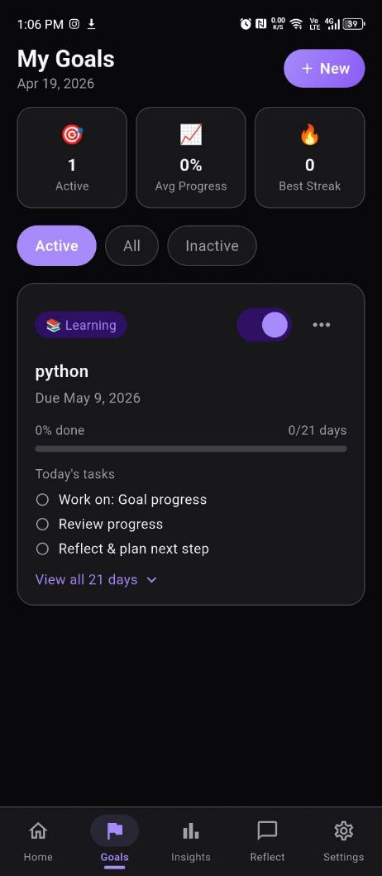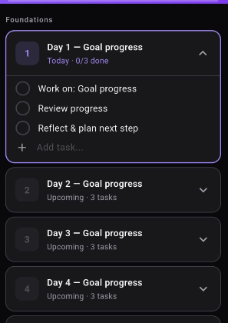
Goal Details Screen:
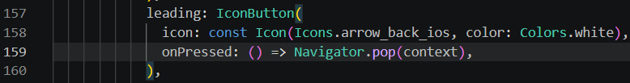
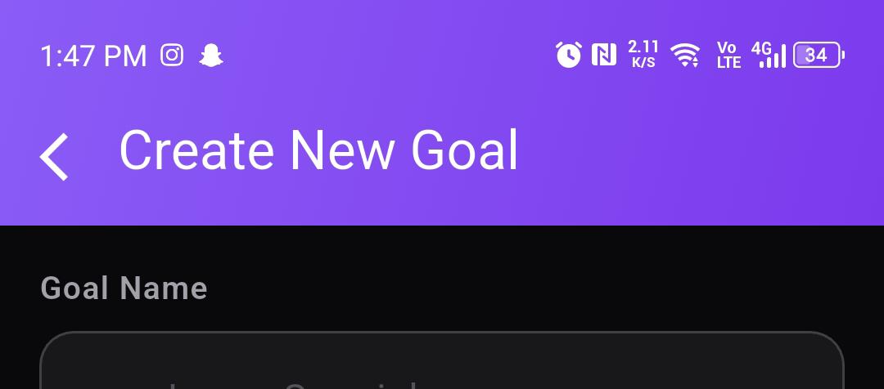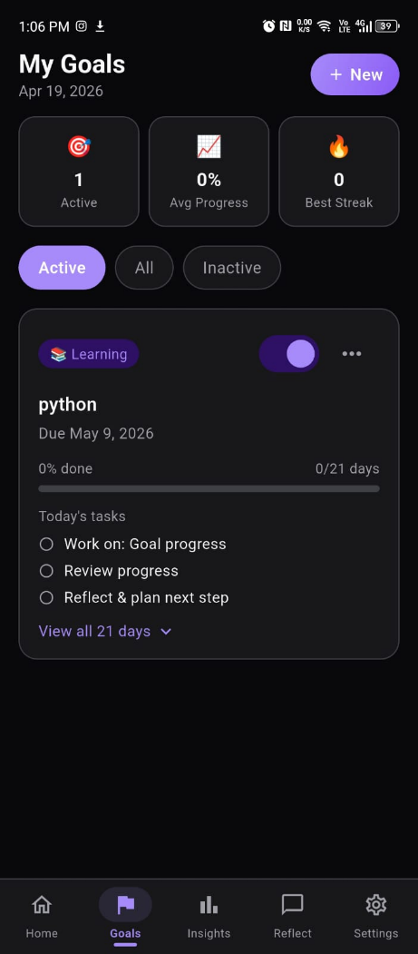

Home screen
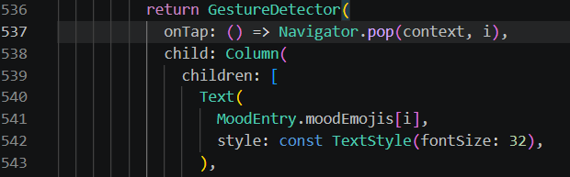
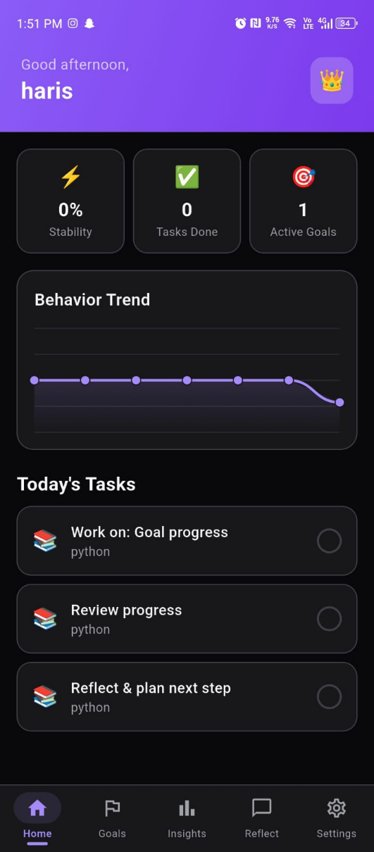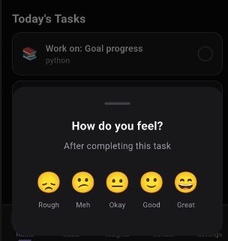
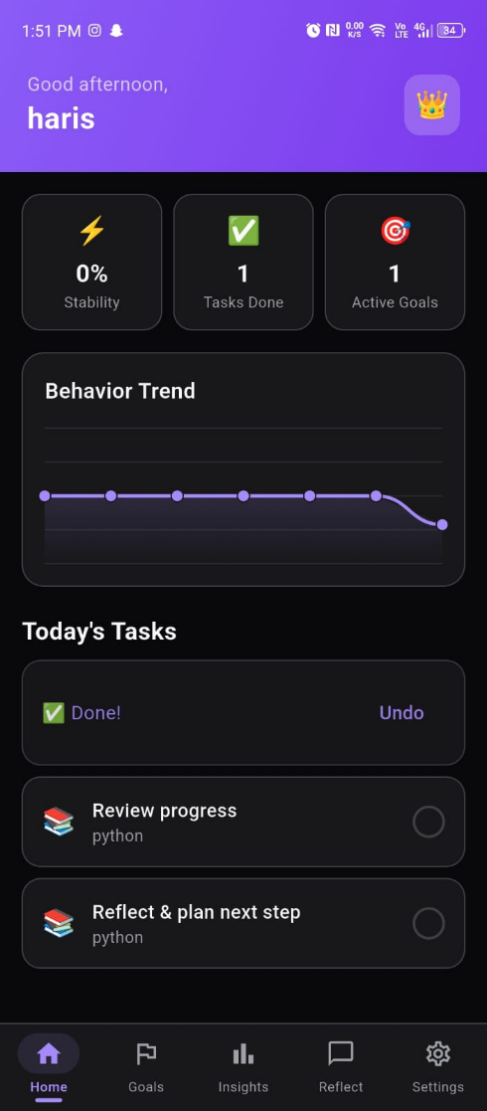
Navigator Push Pop:
- Push: new screen slides in from right.
- Pop: current screen slides out to right, revealing previous screen.
- Both Considered Standard Android/Material navigation pattern.
- Tap goal card pushes the GoalDetailScreen on top slides in from the right.
- White back arrow in the goal detail header tapping it slides screen back off to the right.
- Mood picker tapping an emoji pops the modal AND returns the selected mood index back to the caller.

2. HERO ANIMATION
Goal_screen
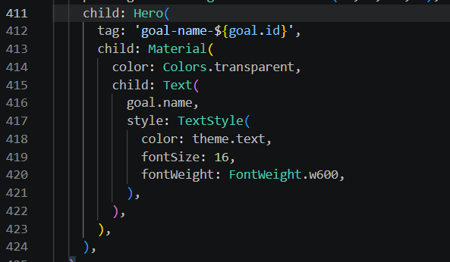
Goal_details_screen
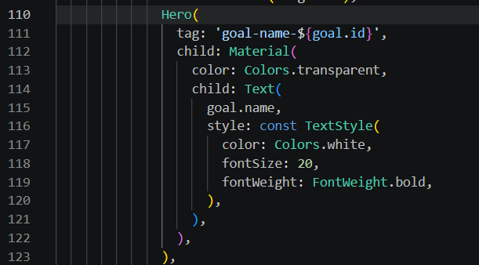

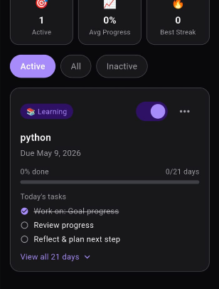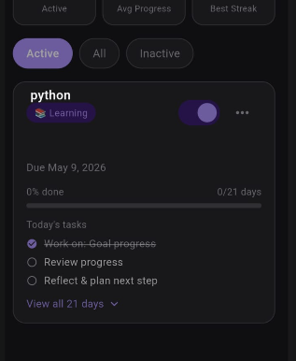
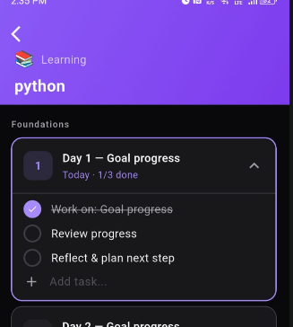

Hero Animation:
- Tap any goal in Goals tab the goal
- Title text flies from the card (dark, 16px) to the detail screen header (white, 20px)
- Smoothly morphing size, color and position mid-flight.
- Flutter matches the two Hero widgets by identical tag and animates between them automatically.

3. BOTTOM NAVIGATION BAR
Main screen
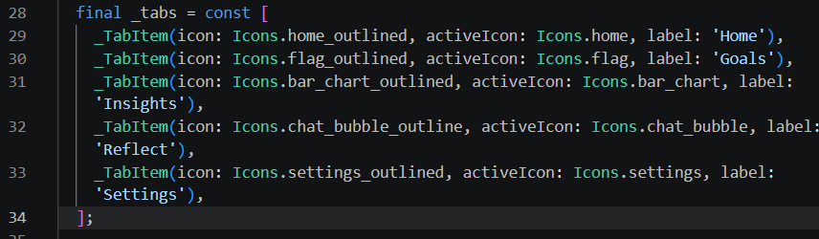
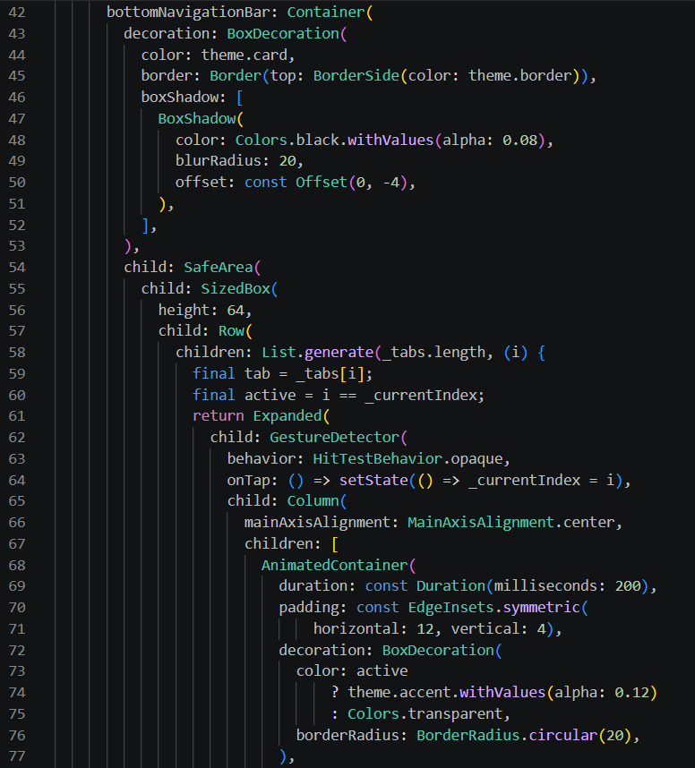
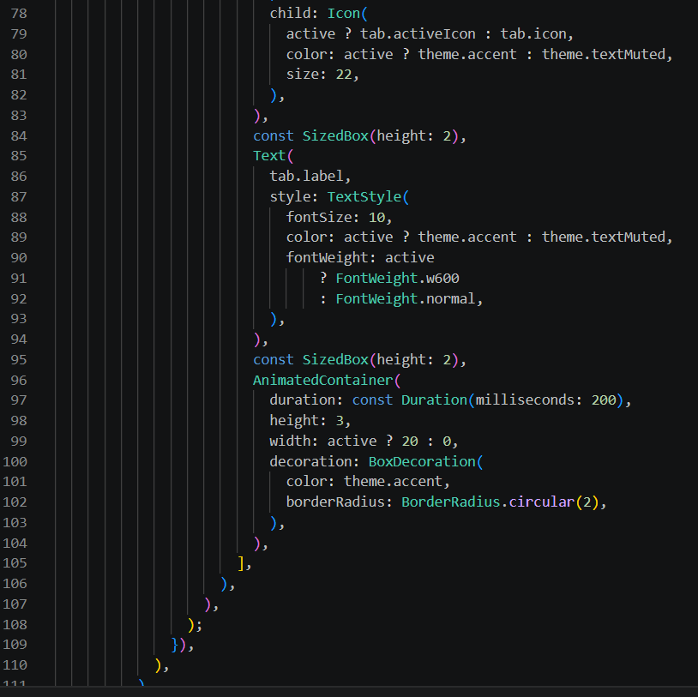
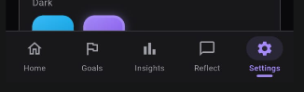
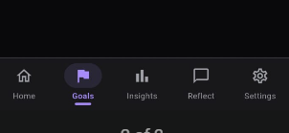
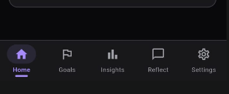
Bottom Navigation Bar:
- Bottom bar with 5 tabs.
- Active tab = filled icon + accent color + light background pill + small underline dot (all animated 200ms).
- Inactive tabs = outlined icon + muted gray.
- Tapping any tab instantly switches the screen content using IndexedStack (keeps state of all screens alive).

